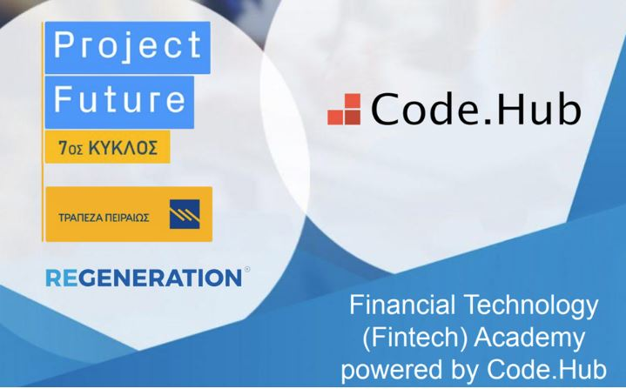Project Assignment Project Future 7

“Financial Technology (Fintech)”

DEcember 21, 2021

*FINTECH ACADEMY* ***TEΑM 2***

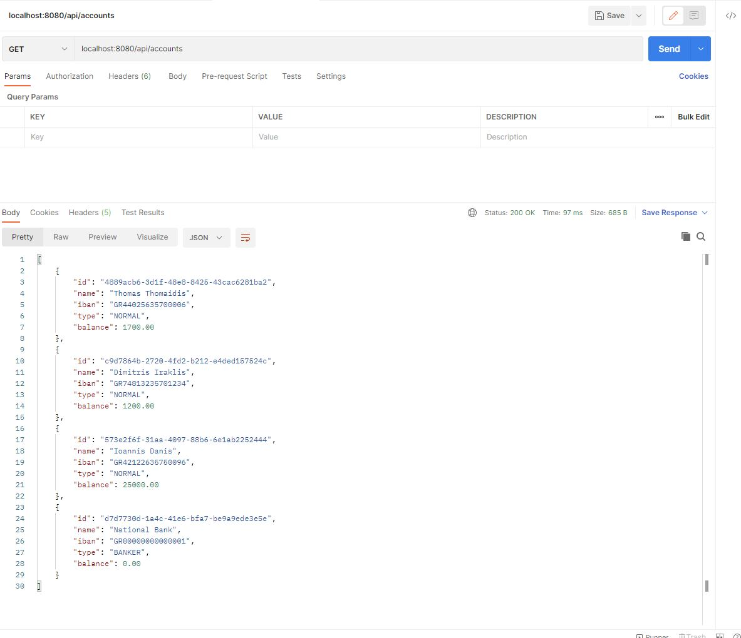

Accounts state before transaction, with GET request via Postman

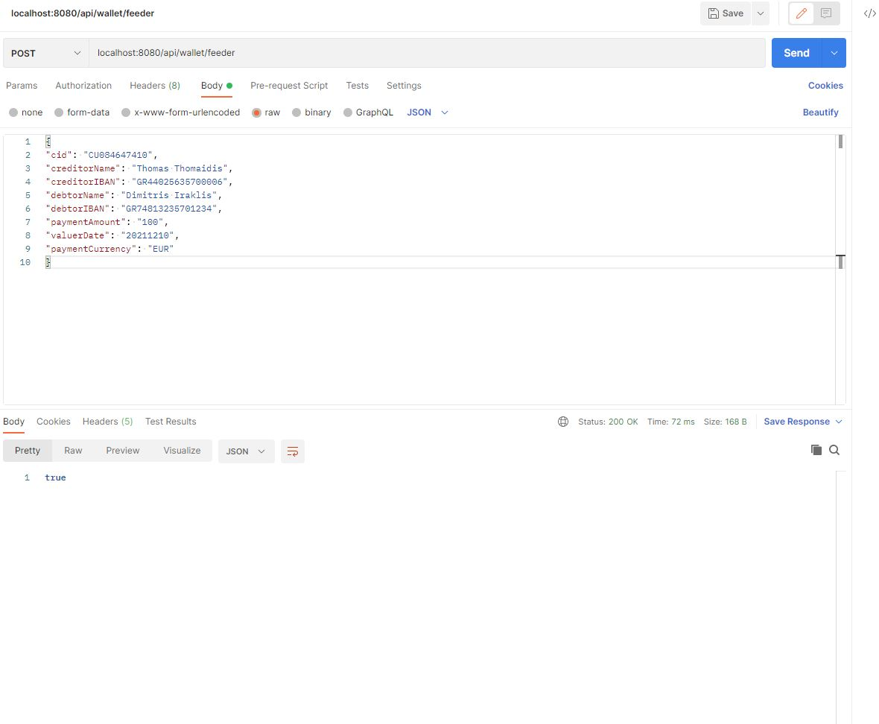

Transaction request, with POST request via Postman

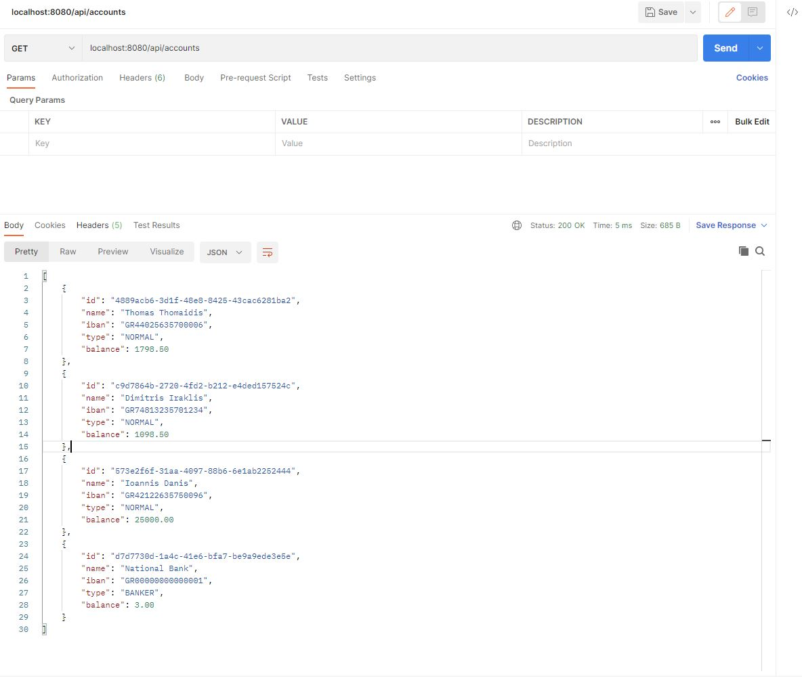

Accounts state after transaction, with GET request via Postman